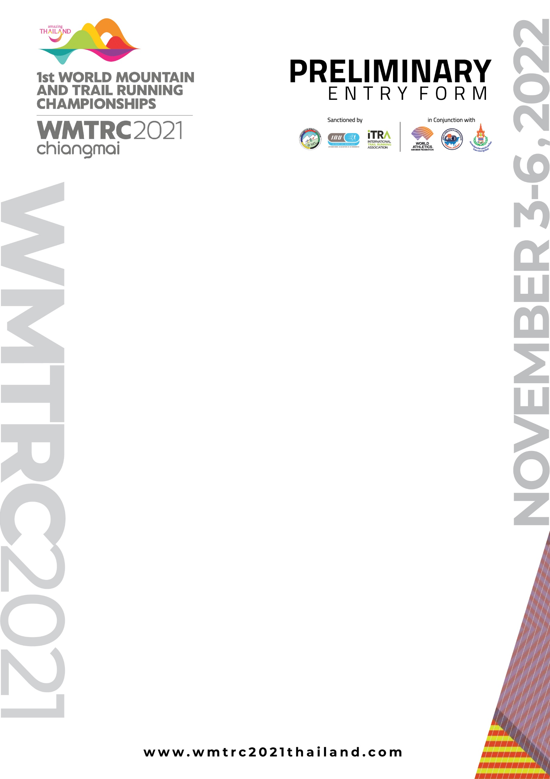
Please fill in the shaded boxes; to be sent to secretariat@wmtrc2021thailand.com

1) Country:
2) Name of Member Federation:
3) Delegation - our delegation will be composed of:
3.1 Long Trail (80km)
- Senior men |  |  | (maximum of 6 to start; 3 to score)
- Senior women |  |  | (maximum of 6 to start; 3 to score)
3.2 Short Trail (40km)
- Senior men |  |  | (maximum of 6 to start; 3 to score)
- Senior women |  |  | (maximum of 6 to start; 3 to score)
3.3 Classic Uphill (8,5km)
- Senior men |  |  | (maximum of 4 to start; 3 to score)
- Senior women |  |  | (maximum of 4 to start; 3 to score)
3.4 Classic Up & Down
- Senior men |  |  | (maximum of 4 to start; 3 to score)
- Senior women |  |  | (maximum of 4 to start; 3 to score)
- Junior men |  |  | (maximum of 4 to start; 3 to score)
- Junior women |  |  | (maximum of 4 to start; 3 to score)
3.5) Officials |  |  | (total; max 4 on the cost of the LOC)
4) International transport: We expect to come (options: Bangkok (BKK/DMK) – Chiang Mai (CNX)
 |  | Group 1 | Group 2 | Group 3 |  | Group 4
Arrivals: | Dates
Int’l flight / Airport
Domestic flight / Airport
Number of passengers
Departures: | Dates
Int’l flight / Airport
Domestic flight / Airport
Number of passengers
Others:
5) WMTRC travel grant will be paid by bank (Transfer after the championships)
Bank Name
Account No / BIC/Swift No.
Date: |  |  |  | Signature:
Name:
Position in the Federation:

